Data Operations
# Source: AI Source: Provided by: [Data Path: Persons Table -> ID Column: 1, Name_En Column: Motasem Essam] -> From: [Chatgpt (GPT‑5 Mini)] on [12/10/2025]
Data Operations means the actions or processes performed on data to organize, change, analyze, or manage it so it becomes useful information.

Simple definition
# Source: AI Source: Provided by: [Data Path: Persons Table -> ID Column: 1, Name_En Column: Motasem Essam] -> From: [Chatgpt (GPT‑5 Mini)] on [12/10/2025]
👉 Data operations = the tasks done on data to process or manipulate it.

Common Data Operations
# Source: AI Source: Provided by: [Data Path: Persons Table -> ID Column: 1, Name_En Column: Motasem Essam] -> From: [Chatgpt (GPT‑5 Mini)] on [12/10/2025]
- Collection
- Storage
- Retrieval
- Caching
- Create
- Insert
- Updating
- Deletion
- Sorting
- Filtering
- Analysis
- Validation
- Sanitization
- Cleaning / Preprocessing
- Aggregation
- Transformation
- Merging / Joining
- Indexing
- Visualizing
- Sharing / Use
- Backup & Recovery
- Transaction

Collection 📥
# Source: AI Source: Provided by: [Data Path: Persons Table -> ID Column: 1, Name_En Column: Motasem Essam] -> From: [Chatgpt (GPT‑5 Mini)] on [12/10/2025]
Definition:
Gathering data from sources.
Example:
A teacher collects student scores from a test.
Data collected:
Ali – 85, Sara – 90, Omar – 70

Storage 💾
# Source: AI Source: Provided by: [Data Path: Persons Table -> ID Column: 1, Name_En Column: Motasem Essam] -> From: [Chatgpt (GPT‑5 Mini)] on [12/10/2025]
Definition:
Saving data in a place like a database, file, or memory.
Example:
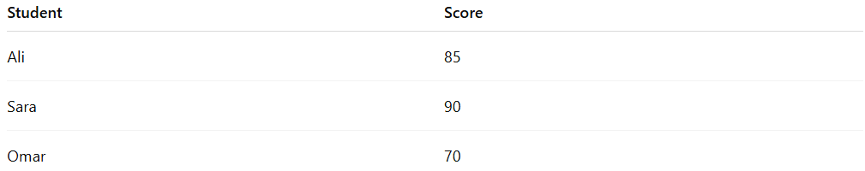
Student | Score
Ali | 85
Sara | 90
Omar | 70

Retrieval 🔎
# Source: AI Source: Provided by: [Data Path: Persons Table -> ID Column: 1, Name_En Column: Motasem Essam] -> From: [Chatgpt (GPT‑5 Mini)] on [12/10/2025]
Definition:
Getting data when needed.
Example:
The teacher searches for Sara's score in the database.
Result: Sara – 90

Caching ⚡
# Source: AI Source: Provided by: [Data Path: Persons Table -> ID Column: 1, Name_En Column: Motasem Essam] -> From: [Chatgpt (GPT‑5 Mini)] on [12/10/2025]
Definition:
Storing frequently accessed data in a temporary storage (cache) to allow faster retrieval in the future.
Example:
A teacher checks Sara’s score multiple times:
- First request → retrieved from database (slow)
- Second request → retrieved from cache (fast)
✔ Improves performance and reduces repeated database queries

Create 🏗️
# Source: AI Source: Provided by: [Data Path: Persons Table -> ID Column: 1, Name_En Column: Motasem Essam] -> From: [Chatgpt (GPT‑5 Mini)] on [12/10/2025]
Definition:
Defining a new dataset, table, or data structure from scratch.
Example:
Creating a new student table in a database with columns: ID, Name, Score.
Resulting table (empty):
ID | Name | Score

Insert ➕
Definition:
Adding new records or data entries into an existing dataset or database.
Example:
Adding a new student to the class.
Before insert: Ali – 85, Sara – 90, Omar – 80
After insert: Ali – 85, Sara – 90, Omar – 80, Lina – 95

Updating ✏️
# Source: AI Source: Provided by: [Data Path: Persons Table -> ID Column: 1, Name_En Column: Motasem Essam] -> From: [Chatgpt (GPT‑5 Mini)] on [12/10/2025]
Definition:
Changing existing data.
Example: updating a student's phone number.
Example:
Omar retakes the test and his score changes.
Before update: Omar – 70
After update: Omar – 80

Deletion ❌
# Source: AI Source: Provided by: [Data Path: Persons Table -> ID Column: 1, Name_En Column: Motasem Essam] -> From: [Chatgpt (GPT‑5 Mini)] on [12/10/2025]
Definition:
Removing data that is no longer needed.
Example:
If a student leaves the class, the teacher removes their record.
Before deletion: Ali – 85, Sara – 90, Omar – 80
After deletion: Ali – 85, Sara – 90

Sorting 🔢
# Source: AI Source: Provided by: [Data Path: Persons Table -> ID Column: 1, Name_En Column: Motasem Essam] -> From: [Chatgpt (GPT‑5 Mini)] on [12/10/2025]
Definition:
Arranging data in order (ascending or descending).
Example: sorting scores from lowest to highest.
Example:
Sorting scores from lowest to highest.
Before sorting: 85, 90, 70
After sorting: 70, 85, 90

Filtering 🎯
# Source: AI Source: Provided by: [Data Path: Persons Table -> ID Column: 1, Name_En Column: Motasem Essam] -> From: [Chatgpt (GPT‑5 Mini)] on [12/10/2025]
Definition:
Selecting specific data from a large dataset.
Example: showing students with marks above 80.
Example:
Show students with scores above 80.
Data: Ali – 85, Sara – 90, Omar – 70
Filtered result: Ali – 85, Sara – 90

Analysis 📊
# Source: AI Source: Provided by: [Data Path: Persons Table -> ID Column: 1, Name_En Column: Motasem Essam] -> From: [Chatgpt (GPT‑5 Mini)] on [12/10/2025]
Definition:
Studying data to find patterns or insights.
Example:
The teacher calculates the average score.
Scores: 85, 90, 70
Average: $(85+90+70)÷3=81.67$
So the average class score = 81.67.

Validation ✅
# Source: AI Source: Provided by: [Data Path: Persons Table -> ID Column: 1, Name_En Column: Motasem Essam] -> From: [Chatgpt (GPT‑5 Mini)] on [12/10/2025]
Definition:
Checking if the data is accurate, complete, and in the correct format before storing or processing it.
Example:
A form requires a phone number to be 10 digits.
Input: 12345 → Invalid
Input: 9876543210 → Valid

Sanitization 🧼
# Source: AI Source: Provided by: [Data Path: Persons Table -> ID Column: 1, Name_En Column: Motasem Essam] -> From: [Chatgpt (GPT‑5 Mini)] on [12/10/2025]
Definition:
Removing or modifying sensitive, unsafe, or unwanted parts of data to make it secure and safe for use.
Why it comes after Validation:
- Validation checks if data is correct and properly formatted
- Sanitization makes the validated data safe, clean, and secure
Example:
A user submits input in a form:
Input:
<script>alert("hack")</script> Ali
After sanitization:
Ali
✔ Removes harmful code (prevents attacks like XSS)
✔ Keeps only safe and useful data

Cleaning / Preprocessing 🧹
# Source: AI Source: Provided by: [Data Path: Persons Table -> ID Column: 1, Name_En Column: Motasem Essam] -> From: [Chatgpt (GPT‑5 Mini)] on [12/10/2025]
Definition:
Fixing errors, missing values, duplicates, or irrelevant information in data.
Example:
Original data: Ali, 85, Omar, -, Sara, 90, Ali, 85
After cleaning: Ali, 85, Sara, 90, Omar, (fill missing)

Aggregation 📊
# Source: AI Source: Provided by: [Data Path: Persons Table -> ID Column: 1, Name_En Column: Motasem Essam] -> From: [Chatgpt (GPT‑5 Mini)] on [12/10/2025]
Definition:
Combining data from multiple sources or records to produce a summary or total.
Example:
Calculating total sales from multiple stores:
Store1: $100, Store2: $150 → Total Sales = $250

Transformation 🔄
# Source: AI Source: Provided by: [Data Path: Persons Table -> ID Column: 1, Name_En Column: Motasem Essam] -> From: [Chatgpt (GPT‑5 Mini)] on [12/10/2025]
Definition:
Changing data from one format or structure to another.
Example:
Converting a date from DD/MM/YYYY → YYYY-MM-DD
11/03/2026 → 2026-03-11

Merging / Joining 🔗
# Source: AI Source: Provided by: [Data Path: Persons Table -> ID Column: 1, Name_En Column: Motasem Essam] -> From: [Chatgpt (GPT‑5 Mini)] on [12/10/2025]
Definition:
Combining two or more datasets into one based on a common attribute.
Example:
Student | Score
Ali | 85
Student | Class
Ali | 10A

Merged:
Student | Score | Class
Ali | 85 | 10A

Indexing 🔖
# Source: AI Source: Provided by: [Data Path: Persons Table -> ID Column: 1, Name_En Column: Motasem Essam] -> From: [Chatgpt (GPT‑5 Mini)] on [12/10/2025]
Definition:
Creating a reference system to make retrieving data faster.
Example:
A library catalog: searching for a book by title or author instead of scanning all books.

Visualizing 📈
# Source: AI Source: Provided by: [Data Path: Persons Table -> ID Column: 1, Name_En Column: Motasem Essam] -> From: [Chatgpt (GPT‑5 Mini)] on [12/10/2025]
Definition:
The process of representing data in a visual format like charts, graphs, or plots to make it easier to understand patterns and trends.
Example:
Student scores: Ali – 85, Sara – 90, Omar – 80
Visualized as a bar chart: 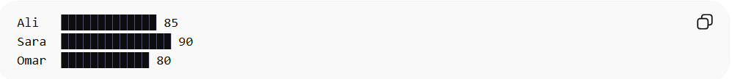
Ali █████████████ 85
Sara ███████████████ 90
Omar ████████████ 80
This makes it easy to compare scores at a glance.

Sharing / Use 🔄
# Source: AI Source: Provided by: [Data Path: Persons Table -> ID Column: 1, Name_En Column: Motasem Essam] -> From: [Chatgpt (GPT‑5 Mini)] on [12/10/2025]
Definition:
Making data accessible to others or applying it for specific purposes.
Example:
- Sending student performance reports to parents.
- Using sales data to make business decisions.
Result: Data is available for collaboration, reporting, or decision-making.

Backup & Recovery 💽
# Source: AI Source: Provided by: [Data Path: Persons Table -> ID Column: 1, Name_En Column: Motasem Essam] -> From: [Chatgpt (GPT‑5 Mini)] on [12/10/2025]
Definition:
Creating a copy of data to prevent loss and restoring it if needed.
Example:
Daily backup of a company database. If the system crashes, data can be restored.

Transaction 🔐
# Source: AI Source: Provided by: [Data Path: Persons Table -> ID Column: 1, Name_En Column: Motasem Essam] -> From: [Chatgpt (GPT‑5 Mini)] on [12/10/2025]
Definition:
A transaction is a group of operations that are executed as a single unit.

👉 Either:
• All operations succeed
• OR all operations fail together
This ensures data consistency and integrity.
Example:
Transferring money between accounts:
Step 1: Deduct $100 from Account A
Step 2: Add $100 to Account B

✔ If both succeed → transaction is committed
❌ If one fails → transaction is rolled back (nothing changes)

Validation vs Cleaning / Preprocessing
# Source: AI Source: Provided by: [Data Path: Persons Table -> ID Column: 1, Name_En Column: Motasem Essam] -> From: [Chatgpt (GPT‑5 Mini)] on [12/10/2025]
- Validation happens before storing or processing data → Prevents bad data from entering.
- Cleaning happens after data is collected → Fixes problems that exist in stored or collected data.
✅ So, they are complementary operations in the data workflow.

Processing Data ⚙️
# Source: AI Source: Provided by: [Data Path: Persons Table -> ID Column: 1, Name_En Column: Motasem Essam] -> From: [Chatgpt (GPT‑5 Mini)] on [12/10/2025]
Processing means performing actions on data to turn it into useful information.
In the previous list, processing includes operations like:
- Sorting 🔢 – arranging numbers (70, 85, 90)
- Filtering 🎯 – selecting specific data (scores above 80)
- Analysis 📊 – calculating averages or totals
- Updating ✏️ – modifying existing data
So processing = the group of operations that change or analyze data.

Organizing Data 📂
# Source: AI Source: Provided by: [Data Path: Persons Table -> ID Column: 1, Name_En Column: Motasem Essam] -> From: [Chatgpt (GPT‑5 Mini)] on [12/10/2025]
Organizing means arranging data in a structured way so it is easier to understand or use.
In the previous list, this mainly happens during:
- Storage 💾 – saving data in tables or databases
- Sorting 🔢 – arranging data in order
Example of organized data:
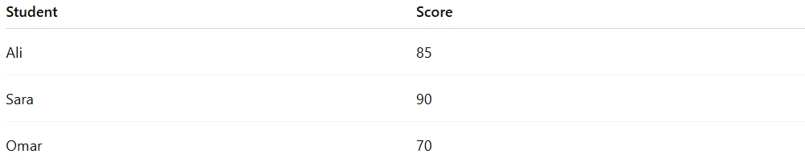
Student | Score
Ali | 85
Sara | 90
Omar | 70

Data Handling
# Source: AI Source: Provided by: [Data Path: Persons Table -> ID Column: 1, Name_En Column: Motasem Essam] -> From: [Chatgpt (GPT‑5 Mini)] on [12/10/2025]
Data handling means the process of collecting, storing, organizing, processing, and using data to get useful information.

🔹 Simple Definition
# Source: AI Source: Provided by: [Data Path: Persons Table -> ID Column: 1, Name_En Column: Motasem Essam] -> From: [Chatgpt (GPT‑5 Mini)] on [12/10/2025]
Data handling = how we work with data from start to finish

🔹 Main Steps of Data Handling
# Source: AI Source: Provided by: [Data Path: Persons Table -> ID Column: 1, Name_En Column: Motasem Essam] -> From: [Chatgpt (GPT‑5 Mini)] on [12/10/2025]
- Collection
  - Gathering data from sources
  - Example: surveys, sensors, user input
- Storage
  - Saving data in memory or databases
  - Could be temporary (RAM) or permanent (disk)
- Organization
  - Arranging data in a structured way
  - Example: tables, lists, files
- Processing
  - Performing operations on data
  - Example: calculations, sorting, filtering
- Presentation
  - Showing data in a useful form
  - Example: charts, reports, dashboards

🔹 Examples
# Source: AI Source: Provided by: [Data Path: Persons Table -> ID Column: 1, Name_En Column: Motasem Essam] -> From: [Chatgpt (GPT‑5 Mini)] on [12/10/2025]
- A website storing login info (cookies & sessions)
- A video app buffering data before playing
- A school system storing and calculating student grades

🔹 Where Data Handling is Used
# Source: AI Source: Provided by: [Data Path: Persons Table -> ID Column: 1, Name_En Column: Motasem Essam] -> From: [Chatgpt (GPT‑5 Mini)] on [12/10/2025]
- Programming
- Databases
- Web development
- Operating systems
- Data analysis

🔹 Simple Analogy
# Source: AI Source: Provided by: [Data Path: Persons Table -> ID Column: 1, Name_En Column: Motasem Essam] -> From: [Chatgpt (GPT‑5 Mini)] on [12/10/2025]
Think of data handling like managing files in real life:
- Collect papers → store them in folders → organize → use them → present results

✅ Summary:
# Source: AI Source: Provided by: [Data Path: Persons Table -> ID Column: 1, Name_En Column: Motasem Essam] -> From: [Chatgpt (GPT‑5 Mini)] on [12/10/2025]
Data handling is a broad concept that includes things like:
- Cookies & sessions
- Buffering
- Memory usage
- File systems
All of these are different ways of working with data efficiently.

